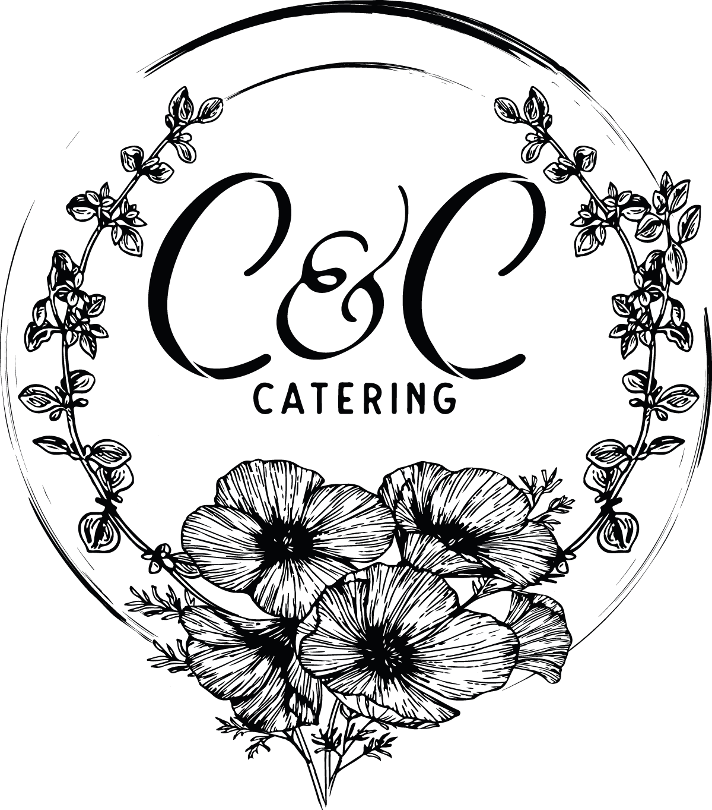

Breakfast and Lunch Catering Menu 2022

530-586-8126

WWW.CCCATERING530.COM

C_C_CATERING@YAHOO.COM

Minimum of 10 Guests per Item Ordered

Breakfast

Build Your Own 1 Main 2 Sides

Main: Buttermilk Pancakes, Belgium Waffles, Vanilla Brandy French Toast, Biscuits & Country Gravy

Sides: Applewood Smoked Bacon, Country Sausage Link, Sausage Patty, Chicken Sausage, Chorizo, Scrambled Eggs, Roasted Rosemary Potatoes

Specialty Breakfast (Includes Fresh Sliced Fruit and Potatoes)

Sourdough Breakfast Sandwich- Choice of Meat, Eggs, Cheddar Cheese and Sriracha Aioli

Chicken and Waffles- Buttermilk Fried Chicken and Cheddar Onion Waffles with Cinnamon Maple Syrup

Breakfast Burritos- Choice of Meat, Potatoes, Cheese, Sour Cream, Guacamole and Salsa

Continental Breakfast
Fresh Sliced Fruit, Muffins, Danishes, Scones, Hard Boiled Eggs, Yogurt and Granola

Bagel Bar
Assorted Bagels, Cream Cheeses, Smoked Salmon, Cucumbers, Pickled Red Onions and Sliced Strawberries

Beverages
Coffee or Tea Bar
Fresh Brewed Coffee, Regular and/or Decaffeinated, Assorted Creamers and Sugars

Fruit Infused Water
Orange Juice
Pineapple Juice
Apple Juice

Sandwiches
(Served with Choice of Soup or Side Salad)

Italian Sub with Ham, Salami, Capicola, Provolone, Pepperoncini, Olives, Shredded Lettuce, Tomato and Red Wine Vinaigrette
Club Sandwich with Turkey, Ham, Cheddar, Bacon, Lettuce, Tomato, Avocado and Garlic Aioli
Grilled Chicken on Ciabatta with Brie, Caramelized Onions and Sun-Dried Tomato Pesto
BBQ Pulled Pork on Brioche with Apple Bourbon Sauce
French Dip on with Shaved Rib-Eye and Au Jus
Chicken Parmesan on Italian Roll with Parmesan and Marinara
Build Your Own Sandwich Bar – Assorted Breads, Deli Meats, Cheeses, Condiments and Toppings

Barbeque
1 Meat 2 Sides

Meats: Chicken Breast, Chicken Thighs, Tri-Tip and Pulled Pork
Sauces: Classic BBQ, Apple Bourbon, Roasted Garlic, Corona Lime, Carolina Mustard and Dr. Pepper
Sides: Grilled Vegetables, Roasted Potatoes, Mashed Potatoes, Bourbon and Bacon Baked Beans, Ranch Style Beans, Mac N Cheese and Fresh Fruit

All BBQ Selections Include Corn Bread and Side Salad

Across the Border
Taco, Fajita or Enchilada Bar:

Flour and/or Corn Tortillas
Meats: Pollo Asada, Carne Asada, Pork Carnitas and Al Pastor
Rice: Cilantro Lime or Spanish
Beans: Black, Refried or Whole Pinto
Includes: Side Salad, Chips, Salsa, Shredded Cabbage, Sour Cream, Guacamole, Jalapeños and Limes
Specialty Dishes:
Chicken Mole
Al Pastor Pork
Chicken Chile Verde
Chimichurri Steak
Chicken or Steak with Mango Jalapeño Salsa
Specialty Dishes Include Side Salad, Rice, Beans, Chips and Salsa

Far East Selections
Pho Bar:
Meats: Chicken, Steak, Shrimp or Tofu.
Includes: Rice Noodles, Onions, Jalapeños, Bean Sprouts, Basil, Cilantro, Green Onions and Lime
Specialty Dishes:
Shoyu Chicken
Katsu Chicken Curry
Mongolian Beef
Kalua Pork
Specialty Dishes Include Side Salad, Choice of Fried Rice or Coconut Rice and Stir Fry Vegetables
Specialty Dishes
(Served with Salad and Bread)

Greek Kebabs- Tzatziki, Roasted Potatoes and Feta Steak or Chicken
Spanish Paella – Chicken, Sausage or Shrimp
Moroccan Chicken Tagine- Spiced Chicken Thighs with Lemon, Olives, Couscous and Roasted Vegetables
Sicilian Sausage Lasagna with Sun Dried Tomato Cream Sauce
Chicken Piccata with Angel Hair Pasta
Jambalaya with Chicken, Sausage and Shrimp

Entrée Salads
(All salads served with local artisan sourdough bread)
Mixed Green Salad with Chicken Breast, Walnuts and Bleu Cheese
Salad Niçoise with Tuna, Potatoes, Green Beans, Hard Boiled Eggs, Olives and Garlic Vinaigrette
Caesar Salad with Roasted Tomatoes, Garlic Croutons and Parmesan Crisp Add Chicken or Steak
Oriental Steak Salad with Mandarin Oranges, Toasted Almonds, Peas, Chow Mein Noodles and Sesame Ginger Dressing
Chop Salad with Salami, Mozzarella, Pepperoncini, Olives, Red Onions and Italian Vinaigrette

Soups
(All soups served with local artisan sourdough bread)
(Available as a Side or Main)

Corn Chowder
Tomato Basil
Split Pea
Loaded Baked Potato
Minestrone

Side Salads

Garden Salad with Carrots, Cucumber and Tomato
Mixed Greens Salad with Strawberries, Cucumber, Mint and Feta Cheese
Romaine Salad with Black Beans, Pico de Gallo, Avocado and Cilantro Vinaigrette

Penne Pasta Salad with Tomato, Artichoke Heart, Olives and Basil Vinaigrette
Greek Potato Salad with Green Onions, Rosemary, Oregano and Lemon Vinaigrette
Dressing Options: Ranch, Bleu Cheese, Italian, Poppy Seed, Citrus Vinaigrette, Cider Vinaigrette

Dessert

Fresh Baked Cookies $2
Decadent Chocolate Brownies $3
Fresh Fruit Platter with Berries. $3
Lemon Bars $4
Blueberry Brandy Bread Pudding $4

Beverages
(All Lunches Include 2 Beverage Choices)

Fruit Infused Water -Included

Agua Fresca -Included

Minted or Regular Iced Tea -Included

Strawberry or Regular Lemonade -Included

Coffee Bar- Add $2

Hansen’s Sodas- Add $2

